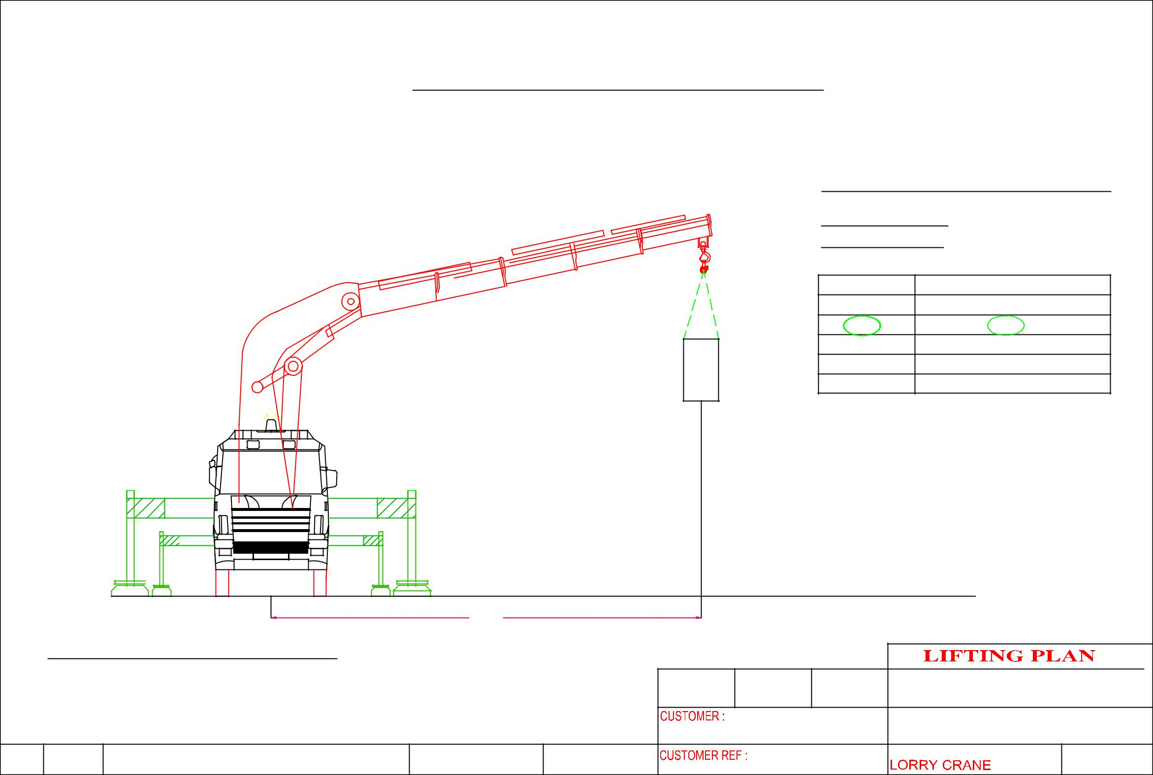
 |  |  | HOISTING OF MACHINE AT 1st FLOOR
 |  |  |  |  |  |  |  | CRANE :PALFINGER PK50002EH
 |  |  |  |  |  |  |  | LORRY CRANE
 |  |  |  |  |  |  |  | CRANE CONFIGURATI0N
 |  |  |  |  |  | m6 |  | OPERATING RADIUS : 6m
 |  |  |  |  |  |  |  | ^{OPT . RADIUS(m)} |  | LIFTING CAPACITY OF CRANE IN KG
 |  |  |  |  |  |  |  | 4 |  |  | 9900
 |  |  |  |  |  |  |  | 6 |  |  | 7000
 |  |  |  |  |  |  |  | 8 |  |  | 5200
 |  |  |  |  |  |  |  | 10 |  |  | 4000
 |  |  |  |  |  |  |  | 12 |  |  | 3250
 |  |  |  |  | MACHINE WEIGHT: | 4,000 KG |  | SAFETY FACTOR CALCULATION
 |  |  |  |  |  |  |  | WEIGHT OF CARGO |  |  | : 1690 KG
 |  |  |  |  |  |  |  | LIFTING ACCESSORIES WEIGHT : 50 KG
 |  |  |  |  |  |  |  | TOTAL WEIGHT OF LIFTING |  |  | : 1740 KG
 |  |  |  |  |  |  |  | LIFTING CAPACITY |  |  | : 7000 KG
 |  |  |  |  |  |  |  | SAFETY FACTOR |  |  | : 4022 KG
 |  |  |  | 6000
 | CRANE :PALFINGER PK50002EH
 |  |  |  |  |  | DRAWN | APPROVED | DATE | ERIC WONG MACHINERY TRANSPORTATION P/L
 |  |  |  |  |  |  | LHY Engineering Pte Ltd |  | DRAWING NAME:
 |  |  |  |  |  |  |  |  | HOISTING OF MACHINE

